A User Interface (UI) is the part of an application that users can see and interact with.
Flutter creates the UI using Widgets.
Everything in Flutter is a Widget.
An ElevatedButton is a raised button with a background color and shadow. It is used to perform an action when the user taps it.
ElevatedButton(
style: ElevatedButton.styleFrom(
backgroundColor: Colors.green,
padding: EdgeInsets.all(16),
),
onPressed: () {},
child: Text("Submit"),
)
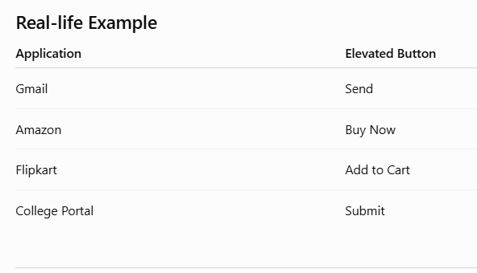
"Why do Android apps look similar?"
Because they follow Google's Material Design.
Flutter provides Material Components to create modern Android-style applications.
Material Components are ready-made widgets provided by Flutter that follow Google's Material Design guidelines.
CUSTOM WIDGETS:
Instead of writing an ElevatedButton, we are using our own widget.
This improves:
- Code Reusability
- Readability
- Maintenance
kDebugMode is a constant provided by Flutter (from the foundation.dart package) that checks whether the application is running in Debug Mode.
- If the app is running in Debug Mode, kDebugMode is true.
- If the app is running in Release Mode (the version given to users), kDebugMode is false.
Therefore, the code inside the if block runs only during development.
final VoidCallback onPressed;
Stores the function executed when the button is pressed.
VoidCallback means:
- No parameters
- No return value
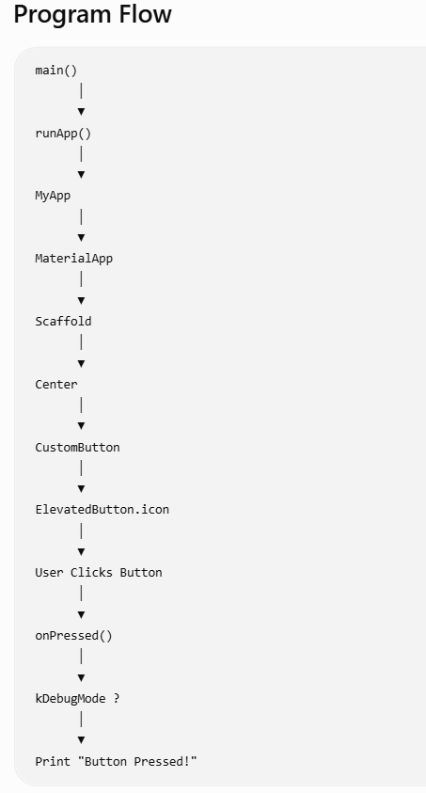

ThemeData is used to apply a common design (colors, fonts, button styles, etc.) throughout the Flutter application.
Instead of changing colors on every screen, define them once.
TextTheme Class
TextTheme stores multiple predefined text styles.
Examples:
- Heading
- Subtitle
- Body
- Caption
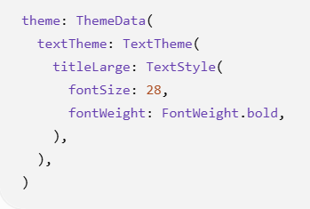
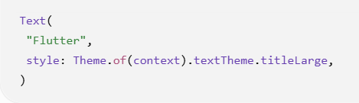
TextStyle Class:

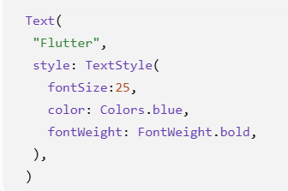
OutlinedButton Class:
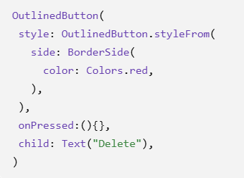
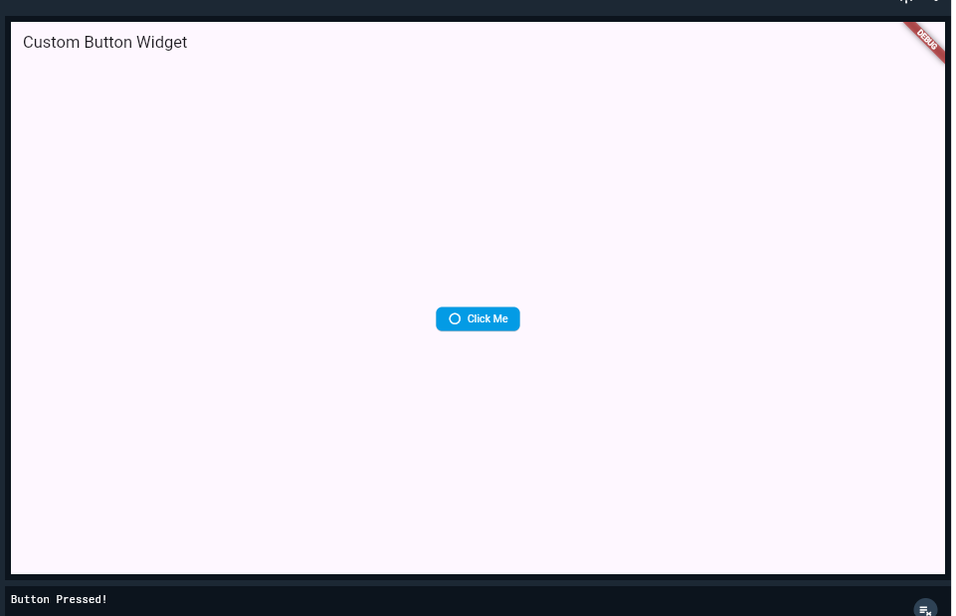

import 'package:flutter/foundation.dart'; // Required for kDebugMode
import 'package:flutter/material.dart';

void main() {
runApp(const MyApp());
}

class MyApp extends StatelessWidget {
const MyApp({super.key});

@override
Widget build(BuildContext context) {
return MaterialApp(
home: Scaffold(
appBar: AppBar(title: const Text('Custom Button Widget')),
body: Center(
child: CustomButton(
text: 'Click Me',
icon: Icons.circle_outlined,
color: Colors.lightBlue[600],
onPressed: () {
if (kDebugMode) {
// Check if the app is running in debug mode
print('Button Pressed!');
}
},
), // CustomButton
), // Center
), // Scaffold
); // MaterialApp
}
}

// Custom Button Widget
class CustomButton extends StatelessWidget {
final String text;
final IconData icon;
final VoidCallback onPressed;
final Color? color, textColor;

const CustomButton(
{super.key,
required this.text,
required this.icon,
required this.onPressed,
this.color = Colors.blueAccent,
this.textColor = Colors.white});

@override
Widget build(BuildContext context) {
return ElevatedButton.icon(
onPressed: onPressed,
icon: Icon(icon, color: textColor),
label: Text(text, style: TextStyle(color: textColor)),
style: ElevatedButton.styleFrom(
backgroundColor: color,
shape: RoundedRectangleBorder(
borderRadius: BorderRadius.circular(8.0),
), // RoundedRectangleBorder
padding: const EdgeInsets.symmetric(horizontal: 16.0, vertical: 12.0),
),
); // ElevatedButton.icon
}
}
import 'package:flutter/material.dart';

void main() => runApp(const MainApp());

class MainApp extends StatefulWidget {
const MainApp({super.key});

@override
State<MainApp> createState() => _MainAppState();
}

class _MainAppState extends State<MainApp> {
bool isDarkTheme = false;

@override
Widget build(BuildContext context) {
return MaterialApp(
theme: isDarkTheme
? ThemeData.dark()
: ThemeData.light().copyWith(
colorScheme: ColorScheme.fromSeed(seedColor: Colors.redAccent)),
home: Builder(builder: (BuildContext context) {
return Scaffold(
appBar:
AppBar(title: Text(isDarkTheme ? 'Dark Theme' : 'Light Theme')),
body: Column(
// mainAxisAlignment: MainAxisAlignment.center, <-- Uncomment to center the widgets
children: <Widget>[
OutlinedButton.icon(
onPressed: () {},
label: const Text('Button'),
icon: isDarkTheme
? const Icon(Icons.dark_mode_rounded)
: const Icon(Icons.light_mode_rounded)),
const SizedBox(height: 20),
SwitchListTile(
title: const Text('Dark Theme'),
value: isDarkTheme,
onChanged: (value) {
setState(() {
isDarkTheme = value;
});
}),
]
),
);
}),
);
}
}
